### This document is to serve as a guide to completing the “AP Computer Science Principles” 2023 Summer Assignment. We will be learning many difference aspects of Computer Science including Data, the Internet, Programming and Ethics.

### Course Description from the College Board:

### AP Computer Science Principles is an introductory college-level computing course that introduces students to the breadth of the field of computer science. Students learn to design and evaluate solutions and to apply computer science to solve problems through the development of algorithms and programs. They incorporate abstraction into programs and use data to discover new knowledge. Students also explain how computing innovations and computing systems—including the internet—work, explore their potential impacts, and contribute to a computing culture that is collaborative and ethical.

### Here is a link to the College Board’s website that details the course: <https://apcentral.collegeboard.org/courses/ap-computer-science-principles>

**Summer Assignment:**

We will be using many resources throughout the year including W3Schools online interactive textbook and programming interface. This is free resource; your assignment is to register yourself at this link (<https://www.w3schools.com/>). Please use a name that I can recognize as you. You will start with the JavaScript Tutorial section of this website: (<https://www.w3schools.com/js/default.asp>)

You are to complete the first four sections. Start with “JS Introduction” and work down the list through to “JS Syntax”. Be sure to save your progress as we will be submitting it at the start of school.

It looks like this:

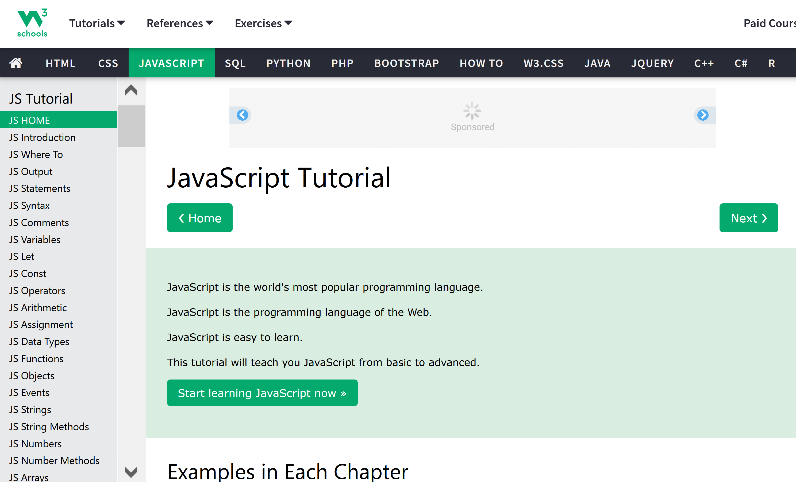

**Optional**, but recommended, view the first few episodes of the YouTube tutorial listed below:

CS Principles - <https://www.youtube.com/watch?v=Kn6Fd5uwZno&list=PLzdnOPI1iJNdVYhNyXeP4FsbSH_AkUhxB>